NAFTATECH ENGINEERING CENTRE, OOO ---------------------------------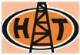------------------------------------------------------------------------------------------------------------------------

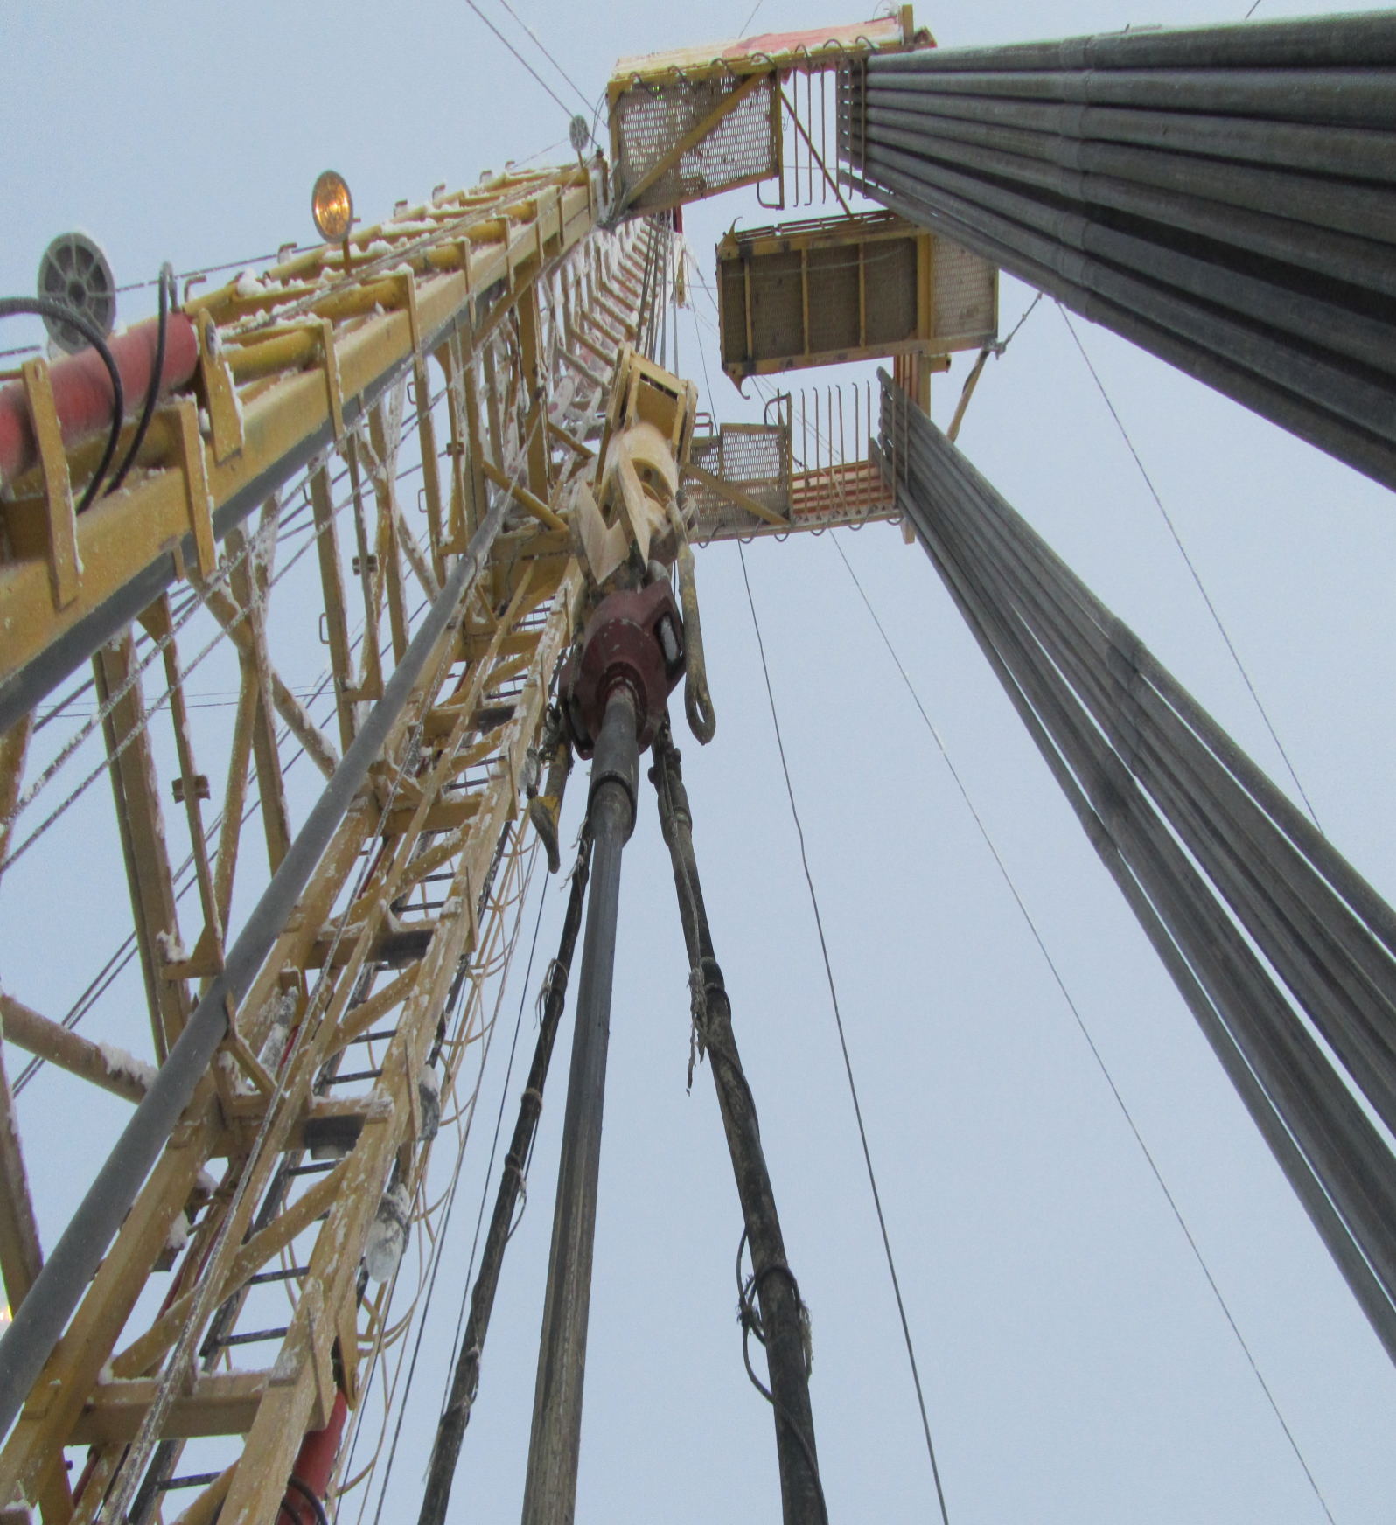

-----------------------------------------------------------------------------------------------------------------------------------------------------------
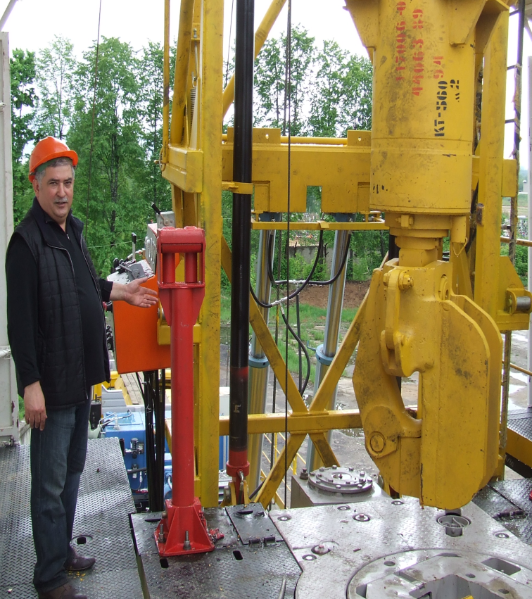

NaftaTech Engineering Centre, OOO represents a professional team comprising designers, production managers as well as maintenance service specialists. The company works in the field of developing, manufacturing and upgrading of oil-and-gas equipment as well as of its servicing, first of all – of mobile drilling rigs of different capacities:
MBU 125, MBU 160, UPT 60 etc., as well as of their separate assemblies, auxiliary equipment and spare parts: draw works, swivels, rotary tables, elevators, tackle systems etc. Our staff provides a complete support of the developed projects ensuring the technical assistance over the full period of the run life of the equipment.

Working under the terms of the severe competition existing at the oil-and-gas equipment market of today’s, the company realizes its main goal as to find the solution of any difficult problem as appropriate not only in a technical but also in a financial sense. At that, the customer’s finance is used very sparingly.

The problem of the necessity of reconstruction and expansion of the mobile drilling rigs’ fleet becomes more and more important for the great majority of drilling companies and companies carrying out capital workover operations. One of the cheapest and, at the same time, the most efficient methods providing the extension of the operating life of the unit, improving its controllability, technical features and safety by minimum investment is, from our point of view, its partial renewal, that is replacement of the mast, the rear support, tackle system, draw works, transmission for the new ones, more advanced, and possessing higher technical characteristics.

This measure enables reducing one-off costs of the drilling company for the renewing of its fleet.

-----------------------------------------------------------------------------------------------------------------------------------------------------------
Such upgrading is a necessary step on the way to bringing the old rig into line with the requirements of the PB 08-624-03 Safety Regulations, and that is one of the main tasks of the recovery and modernization of mobile drilling rigs.
In the course of modernization the following problems are solved:

- The hoisting capacity is increased;
- The rate of drilling rises;
- The costs go down greatly;
- The time for placing the equipment into operation is reduced.
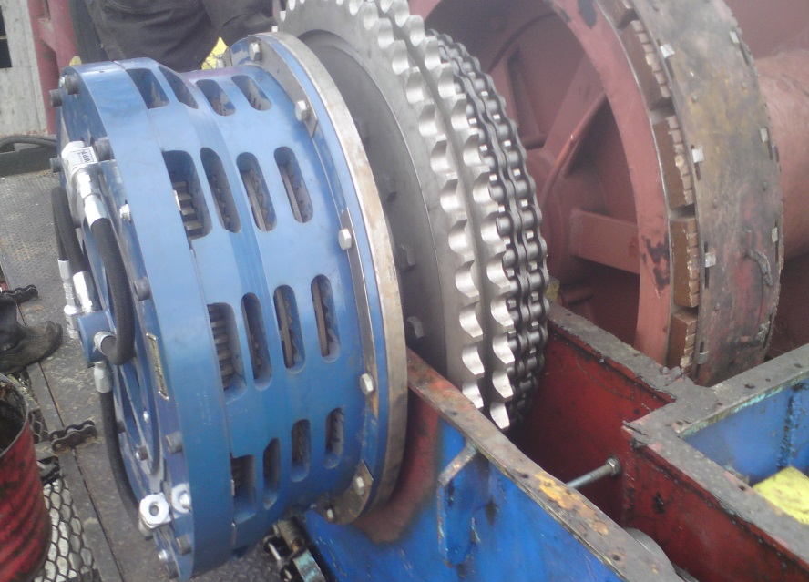
As the result, the equipment acquires characteristics coming up to the modern standards, the working conditions of the drilling crew are improved, the renewal of the mobile drilling rig fleet by immense cost cutting occurs, and on the whole, the competitive performance of the drilling company increases.
For solving the above mentioned tasks, the company takes the next steps:
- upgrades transmissions;
- provides draw works with multidisc pneumatic-mechanical brakes and master clutches (as shown in the picture above);
- upgrades tackle systems;
-upgrades pneumatic systems, hydraulic systems; installs remote control consoles;
- installs drilling information monitoring systems.

The products and services provided by our company are permanently improved with due regard to the requirements for the drilling and workover supervision, to the adaptation of new technologies and to our customers’ preferences.

-----------------------------------------------------------------------------------------------------------------------------------------------------------

The UPT-60 Round-Trip Rig is designed to develop and workover oil and gas wells. This rig differs from its forerunner UPT-50 not only by the increased hoisting capacity but also by a higher mast which makes it possible to use it complete with a convertible wellhead work platform. The rig can be operated in macroclimatic areas with moderate climate, placement category – I according to 15150 GOST standard – by the temperatures from - 45ºС up to + 40ºС.

№ | Parameter | Value
1 | Designation | UPT 60
2 | Drive (engine capacity, kW/ HP) | Т-10МБ.0121-1Tractor (132/180)
3 | Hoisting capacity, kN (ton-force) | 589 (60)
4 | Speed of raising of the travelling block, m/sec | 0,15…….0,80
5 | Hoisting winch:  - traction force on the drum, kN (ton-force)  - drum’s dimensions DxH, mm  - drum clutch  -brake | 123 (12,5)  420x800  Multi-disc type WPTW19-OC-300  Belt-type , mechanically controlled
6 | Mast  - angle lean  - distance from the ground surface to the crown block, no less than, m  - raising of the mast to the working position  - extension of the upper section | telescoping, tilting  5˚  22,5  by means of hydraulic cylinders  by means of a hydraulically controlled winch
7 | Block-and-tackle system:  - reeving  - rope diameter, mm | 3 х 4  25
8 | Hydraulic system:  - number of hydraulic pumps, pcs.  - maximum performance, l/min  - working pressure, no more than, MPa (kgf/m²) | 1  170  15,7 (160)
9 | Pneumatic system:  - working pressure, no more than, MPa (kgf/cm²) | 0,69 (7)
10 | Overall dimensions in travelling condition, mm | 10 500х3 200х4 140
11 | Weight of the unit, no more than, kg | 26350

----------------------------------------------------------------------------------------------------------------------------------------------------------
Force Diagram

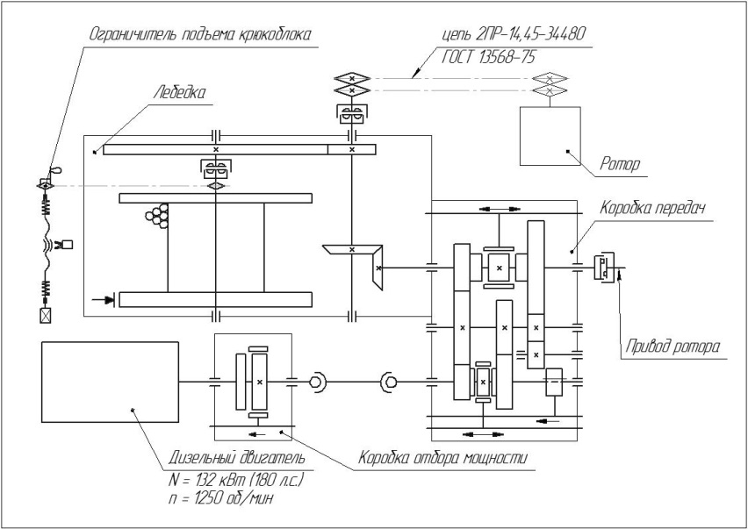

UPT-60 Round-Trip Rig

-----------------------------------------------------------------------------------------------------------------------------------------------------------
MBU 125 Hoisting Unit is designed to carry out round-trip jobs during well drilling, well servicing as well as during workover operations. The Unit can be operated in macroclimatic areas with moderate climate, placement category – I according to 15150 GOST standard – by the temperatures from - 45ºС up to + 40ºС.

№ | Parameter | Value
1 | Designation | MBU 125
2 | Drive (engine capacity, kW/HP) | YaMZ Diesel 8424 (330/ 450)
3 | Hoisting capacity, kN (ton-force) | 1226 (125)
4 | Speed of raising of the travelling block, m/sec. | 0,15…….1,28
5 | Depth of drilling | 2 700
6 | Hoisting winch:  - traction force on the drum, кН (тс)  - drum clutch  - brake  - auxiliary brake | 191 (19,5)  Multidisc-type WPTW321  Belt-type, mechanically controlled  Multidisc-type WPTW321
7 | Mast  - angle lean  - distance from the ground surface to the crown block, no less than, m  - raising of the mast to the operating position  - extension of the upper section | Telescoping, tilting  3˚  38  by means of hydraulic cylinders  by means of hydraulic cylinders or a rope
8 | Block-and-tackle system:  - reeving  - rope diameter, mm | 4 х 5  28
9 | Hydraulic system:  - number of hydraulic pumps, pcs.  - maximum performance, l/ min  - working pressure, no more than, MPa (kgf/ cm²) | 2  170  15,7 (160)
10 | Pneumatic system:  - working pressure, no more than , MPa (kgf/cm²) | С-415 Compressor  0,69 (7)
11 | Overall dimensions in traveling condition, mm | 22 500х3 200х4 700
12 | Weight of the Unit, no more than , kg | 62 000

-----------------------------------------------------------------------------------------------------------------------------------------------------------

MBU 125 Hoisting Unit

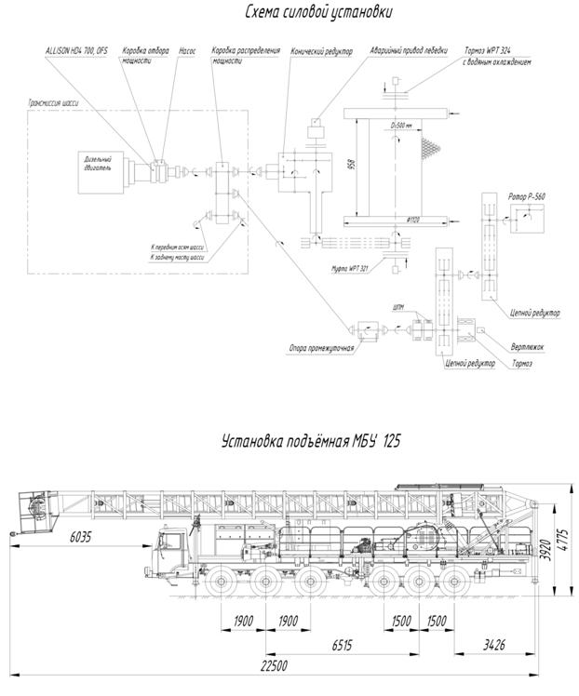

-----------------------------------------------------------------------------------------------------------------------------------------------------------

MBU 160 Selfpropelled Mobile Drilling Rig (maximum load on hook – 160 ton) provided with a Diesel-engine drive is designed for drilling of production and exploratory wells. The Unit can be operated in macroclimatic areas with moderate climate, placement category – I according to 15150 GOST standard – by the temperatures from - 45ºС up to + 40ºС.
№ | Parameter | Value
1 | Designation | MBU 160
2 | Drive (engine capacity, kW/HP) | YaMZ Diesel 8424-010 (375/ 500)
3 | Hoisting capacity, kN (ton-force) | 1 566 (160)
4 | Speed of raising of the travelling block, m/sec. | 0,15…….1,28
5 | Rated depth of drilling, m | 3 500
6 | Hoisting winch:  - traction force on the drum, kN (ton-force)  - drum clutch  - brake  - auxiliary brake | 2 158 (22)  Multidisc-type WPTW324  Belt-type, mechanically controlled  Multidisc-type WPTW324
7 | Mast  - angle lean  - distance from the ground surface to the crown block, no less than, m  - raising of the mast to the operating position  - extension of the upper section | Telescoping, tilting  3º  38  by means of hydraulic cylinders  by means of hydraulic cylinders and a rope
8 | Block-and-tackle system:  - reeving  - rope diameter, mm | 5 х 6  32
9 | Hydraulic system:  - number of hydraulic pumps, pcs.  - maximum performance, l/min  - working pressure, no more than, MPa (kgf/cm²) | 2  170  15,7 (160)
10 | Pneumatic system:  - working pressure, no more than, MPa (kgf/cm²) | Compressor С-415  0,69 (7)
11 | Overall dimensions in traveling condition, mm | 22 500х3 200х4 700
12 | Weight of the Unit, no more than, kg | 68 000

-----------------------------------------------------------------------------------------------------------------------------------------------------------
MBU 160 Mobile Drilling Rig
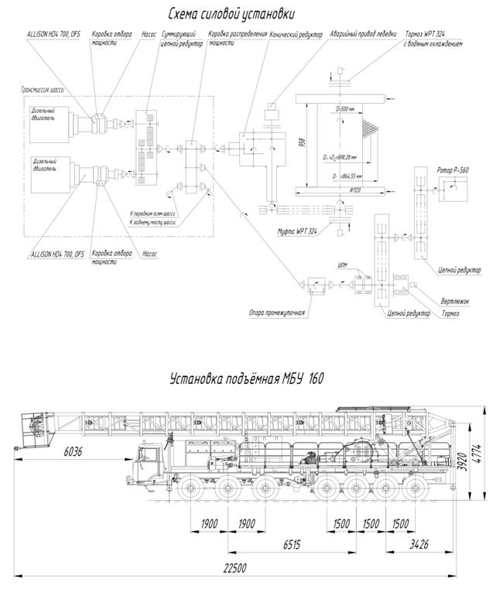

-----------------------------------------------------------------------------------------------------------------------------------------------------------

VB 160 Swivel
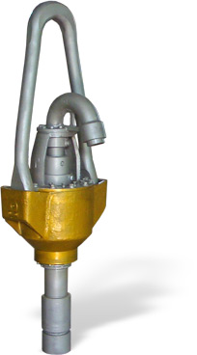
VB 160 Swivel is designed to keep hold a drill string and to deliver drill mud from the pump to the bottom hole under pressure. At the same time it represents an intermediate joint between the reciprocating block-and-tackle system, the drill hose and the spinning drill stem which is fixed on the swivel body by means of a tool-joint thread and provides the opportunity of the pipe movement. The Swivel is hanged on the drilling hook by means of a connecting link.
The main elements of the VB 160 Swivel are indicated in the schematic diagram (see below).
1 — connecting link; 2 — outlet; 3— cover; 4 — wash pipe; 5 — pressure-proof packer; 6— upper oil seal; 7 — body; 8 — upper guide bearing; 9 — joint pins;10 — main step bearing; 11 — lower guide bearing; 12 — lower packer, 13 — swivel body; 14 — adapter

№ | Parameter | Value
1 | Designation | ВБ 160
2 | Static load, kN (ton-force) | 1 600 (160)
3 | Inside diameter, mm | 75
4 | Maximum pressure of the circulating fluid , kgf / cm² | 250
5 | Maximum speed of rotation, RPM | 200
6 | Over all dimensions:  - Pin centerline width, mm  - Width perpendicular to the pin centerline, mm;  - Height, mm | 820  620  2 450
7 | Weight of the complete assembled swivel, kg | 1 435
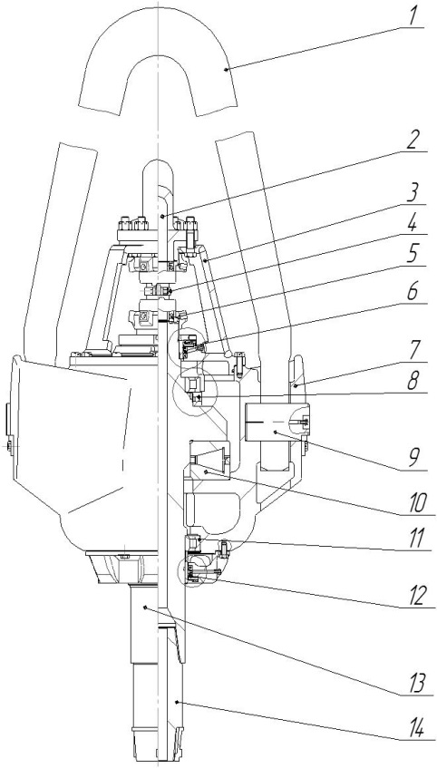

-----------------------------------------------------------------------------------------------------------------------------------------------------------

KM-Type Side Door Elevator

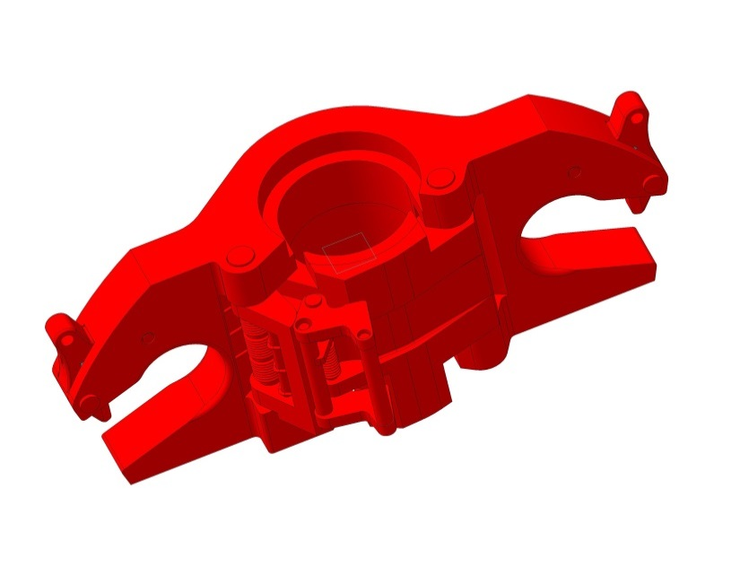
KM-Type Side Door Elevators are designed to take and keep hold drill-stems or casing pipes 60 – 426 mm in diameter during round-trip jobs when drilling oil and gas wells in moderate and cold macroclimatic areas (I₂), according to 16350 - 80 GOST standard (placement category – I according to 15150 – 69 GOST standard).

The elements of the product are indicated in the schematic diagram (see below):

Code | Hoisting capacity, kN (ton-force) | Diameter of pipes, mm | Boring diameter, mm
КМ60-125  КМ73-125  КМ89-125  КМ102-125  КМ114-140  КМ127-140  КМ89-200  КМ102-200  КМ114-250  КМ127-250  КМ140-170  КМ146-170  КМ168-170  КМ178-170  КМ140-320  КМ146-320  КМ168-320  КМ178-320  КМ194-320  КМ219-320  КМ245-320  КМ273-320  КМ299-320  КМ324-320  КМ340-320  КМ351-320  КМ377-320  КМ426-320 | 1250 (125)  1250 (125)  1250 (125)  1250 (125)  1400 (140)  1400 (140)  2000 (200)  2000 (200)  2500 (250)  2500 (250)  1700 (170)  1700 (170)  1700 (170)  1700 (170)  3200 (320)  3200 (320)  3200 (320)  3200 (320)  3200 (320)  3200 (320)  3200 (320)  3200 (320)  3200 (320)  3200 (320)  3200 (320)  3200 (320)  3200 (320)  3200 (320) | 60  73  89  102  114  127  89  102  114  127  140  146  168  178  140  146  168  178  194  219  245  273  299  324  340  351  377  426 | 63  76  92  106  118  131  92  106  118  131  144  150  172  182  144  150  172  182  198  224  250  278  304  331  347  358  384  434

1 – body, 2 – locking spring, 3 – door, 4 – operating lever spring, 5 – connecting links safety device spring, 6 – connecting links safety device, 7 – connecting links safety device axle, 8 – door axle, 9 – operating lever axle, 10 – operating lever, 11 – arresting device, 12 – arresting device axle
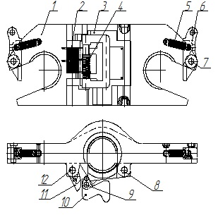

NAFTATECH ENGINEERING CENTRE, OOO ---------------------------------------------------------------------------------------------------------------------------------------------------------

170034, Tver, prospekt Chaykovskogo, 9
Phone/ Fax: + 7 (4822) 45 3858
mail@naftatech.ru
www.naftatech.ru

